
Land Information Ontario (LIO) Warehouse
Data Class Name: CLUPA Provincial
Documentation
Produced by: Information Access and Information Management Policy Unit
Ministry of Natural Resources and Forestry
Date: July 27, 2015

Purpose

This document provides additional information to support the use of geospatial data. The Physical Model Diagram provides a visual representation of the relationships in the data class. The Data Change History lists all the modelling and access changes that have occurred during the lifecycle of the data class. A data description identifying table and field names is available upon request.

Need Assistance?
Please contact LIO Support at lio@ontario.ca or 705-755-1878 if you require help.

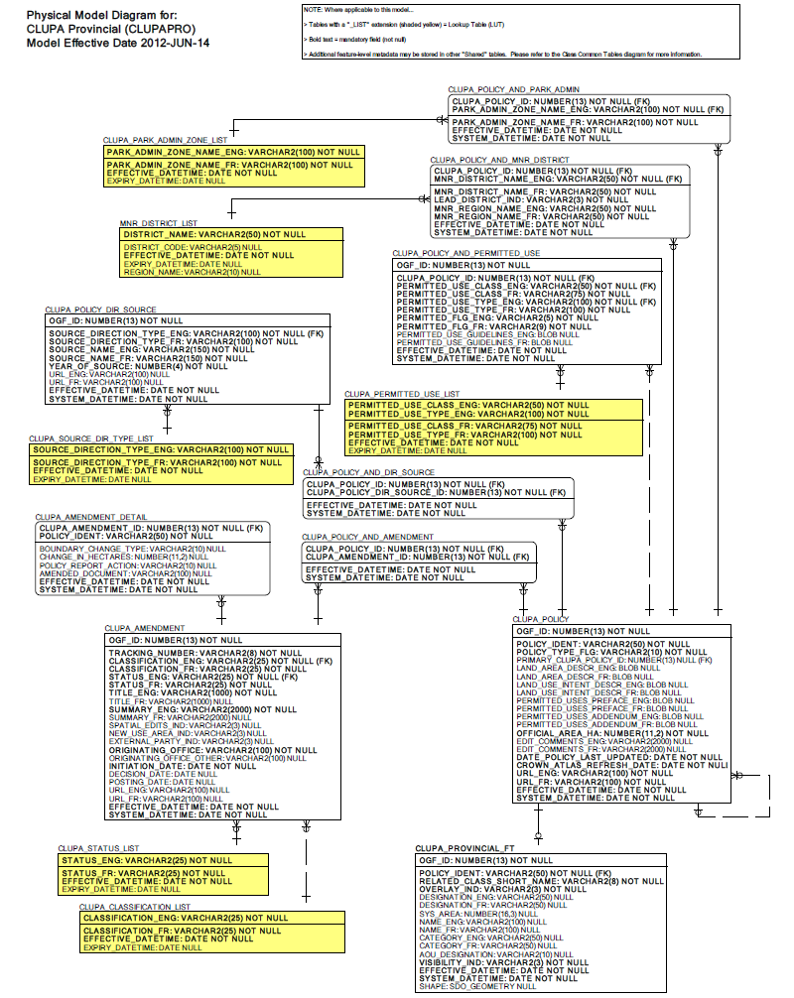
Data Class Change History
Data Class Name: CLUPA Provincial
Data Class Short Name: CLUPAPRO
Date  YYYY-MM-DD | Details of Change
2015-03-10 | Length increased to 254 for the following attributes  CLUPA_POLICY.URL_ENG  CLUPA_POLICY.URL_FR  CLUPA_AMENDMENT.URL_ENG  CLUPA_AMENDMENT.URL_FR  CLUPA_POLICY_DIR_SOURCE.URL_ENG  CLUPA_POLICY_DIR_SOURCE.URL_FR
2012-10-09 | NEW Data Class

Data Description
Please refer to the metadata record for the data description.

